Monthly Coding Tip Sheet Series
February 2026 | American Heart Month
Monthly Focus: Cardiac Conditions & Anesthesia Coding Essentials

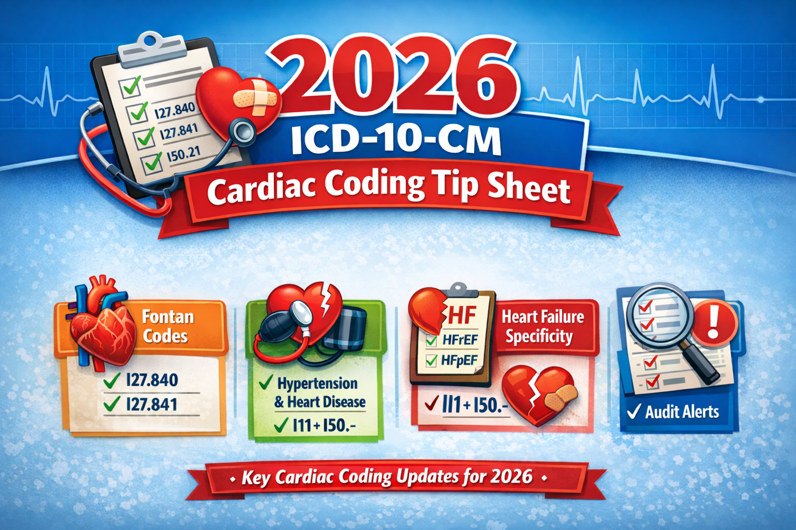

Why This Matters
February is American Heart Month. Cardiovascular conditions significantly impact anesthesia risk assessment, ASA Physical Status assignment, ICD-10-CM specificity, medical necessity, and audit defensibility.

Hypertension (I10–I16)
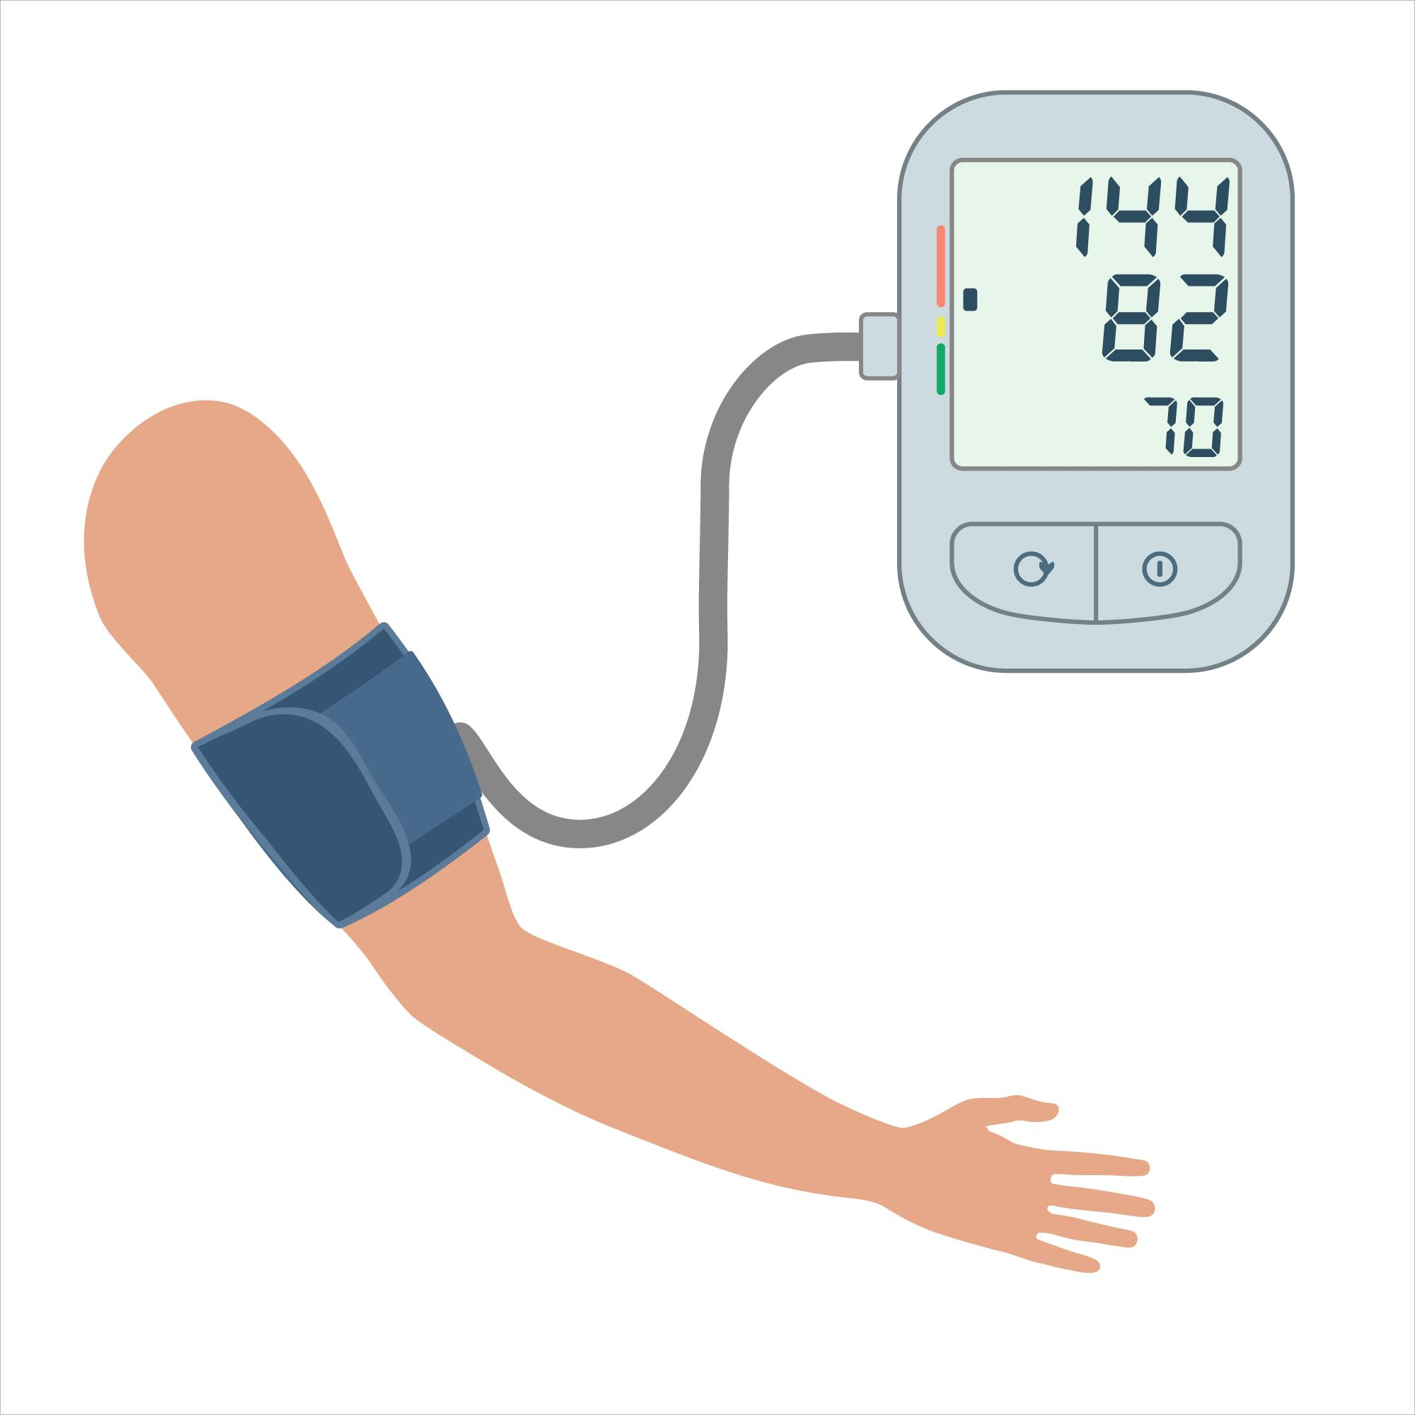
Key Coding Reminders:

- I10 – Essential (primary) hypertension
- I11.- – Hypertension with heart disease
- I12.- – Hypertension with CKD
- I13.- – Hypertension with heart and CKD

Anesthesia Audit Watch Points:

- Controlled vs uncontrolled status documented
- Evidence of hypertensive heart disease?
- CKD staged appropriately?
- ASA level aligned with systemic impact?

Avoid defaulting to I10 when documentation supports combination coding.

Coronary Artery Disease (I25.-)
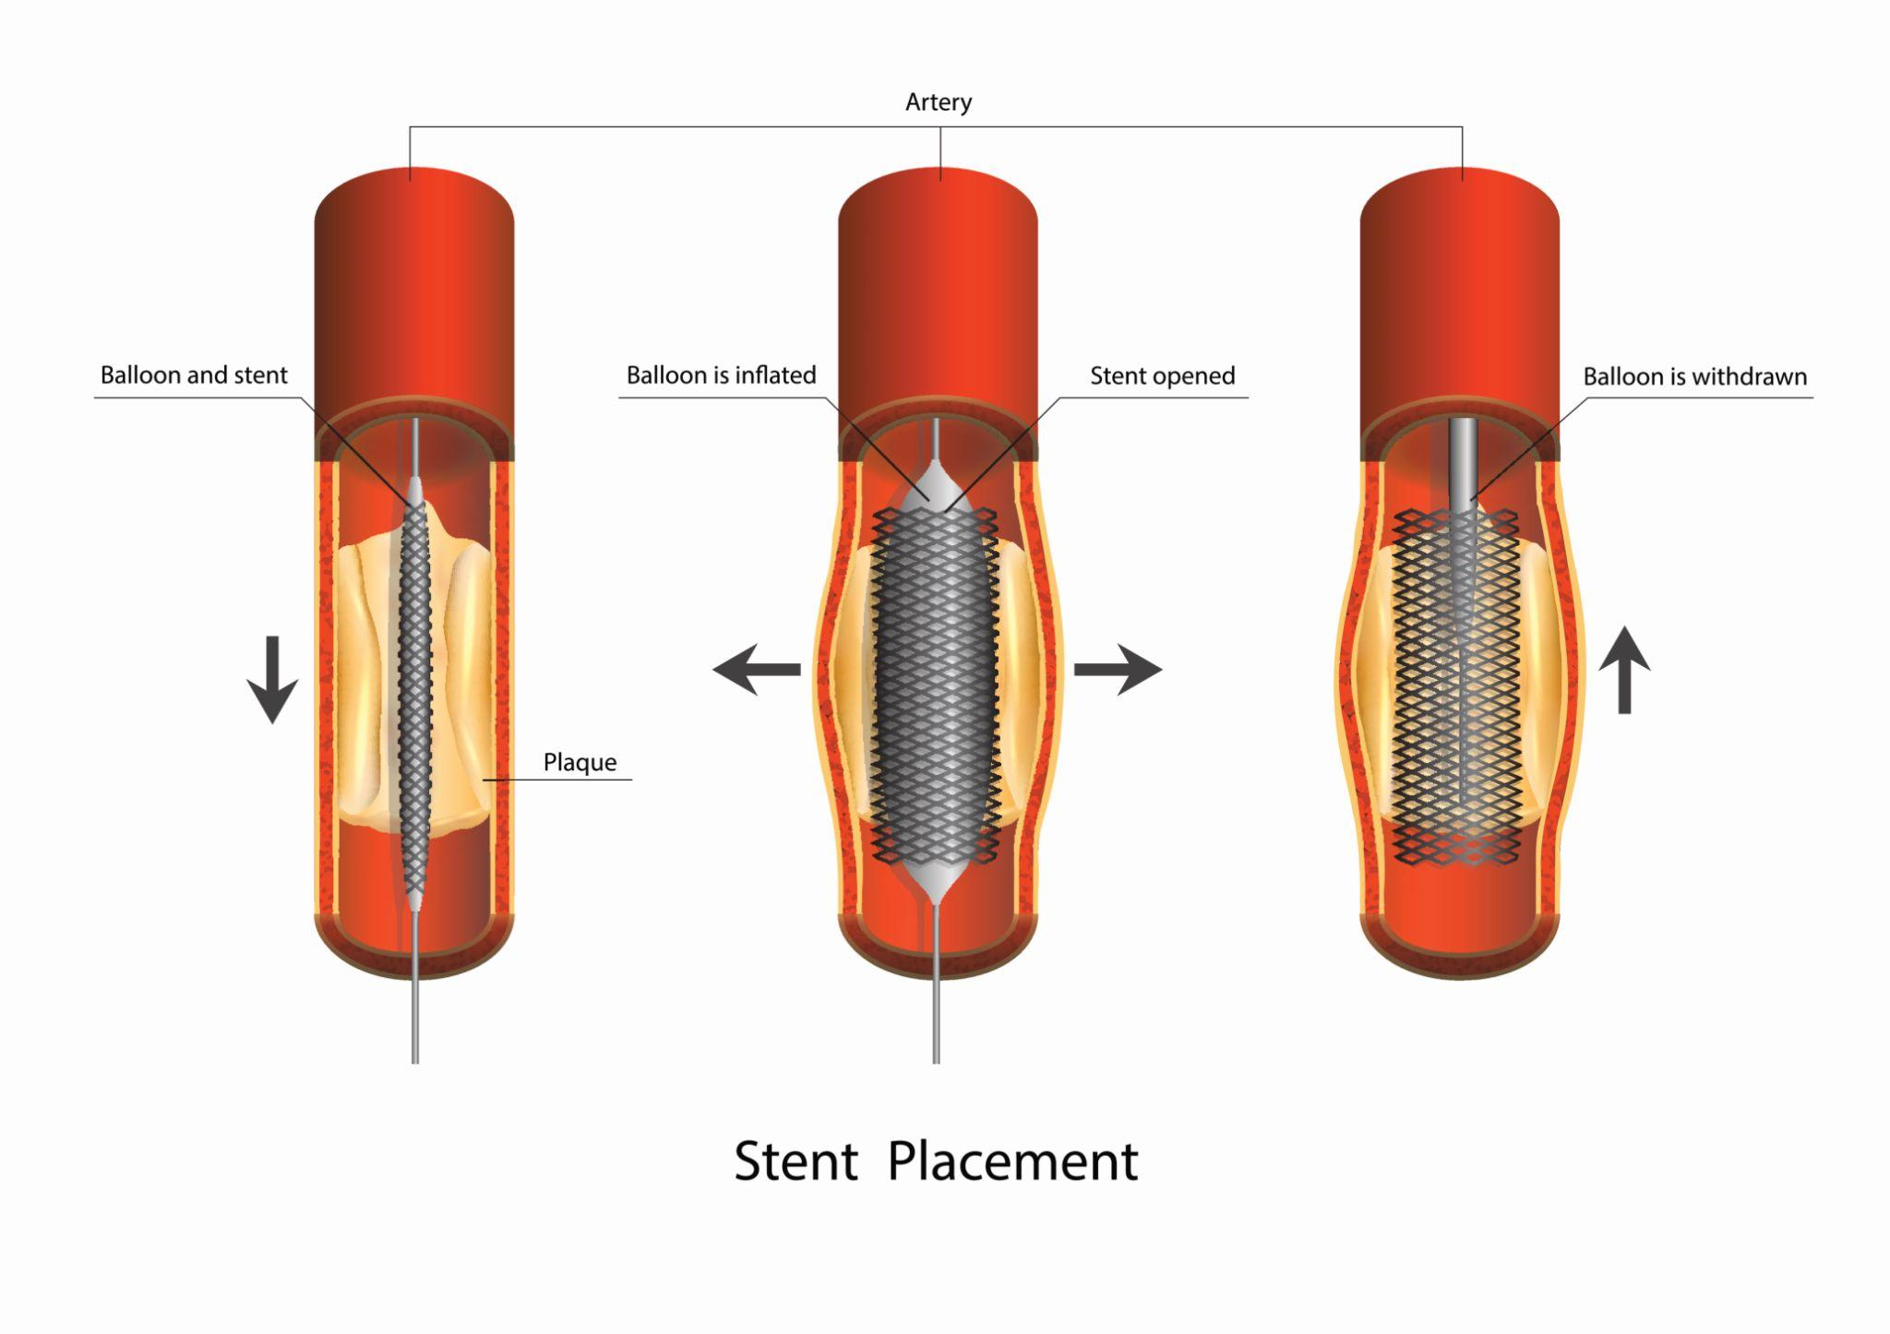

Documentation Specificity:
- Native vessel vs bypass graft
- With or without angina
- Type of angina (stable, unstable, unspecified)
Examples:
- I25.10 – CAD without angina
- I25.110 – CAD with unstable angina
Anesthesia Impact:
- Increased perioperative risk
- May support higher ASA classification
- May influence monitoring and documentation (Medical Direction)

Common Audit Finding:
CAD documented in history – but angina specificity missing.

Heart Failure (I50.-)

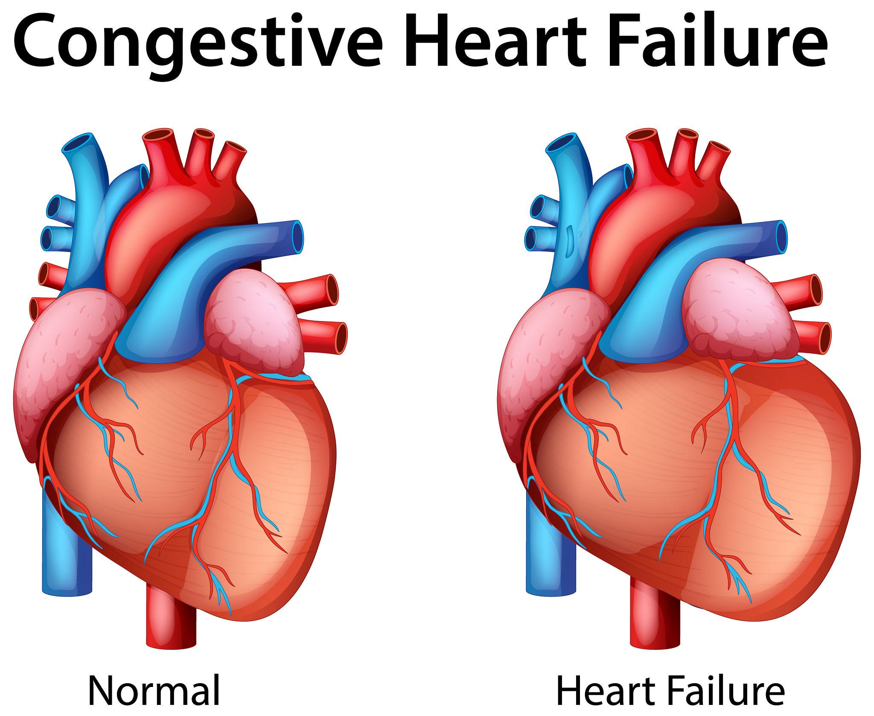
Required Specificity:
- Systolic vs Diastolic vs Combined
- Acute, Chronic, or Acute on Chronic
- Right vs Left vs Biventricular
Examples:
- I50.21 – Acute systolic heart failure
- I50.32 – Chronic diastolic heart failure
- I50.43 – Acute on chronic combined heart failure
Auditor Focus:
- EF percentage documented?
- Diagnosis aligns with pre-op assessment?
- Acute status clinically supported?

High-Risk Audit Area:
“CHF” documented without type or acuity.

ASA Physical Status Considerations
Cardiac conditions frequently influence ASA scoring
Condition | Common ASA Consideration*
Controlled Hypertension | ASA II
CAD with prior MI | ASA III
Symptomatic Heart Failure | ASA III–IV
Always based on full clinical picture and provider documentation.

February 2026 Audit Challenge
- Are cardiac diagnoses coded to highest specificity?
- Does documentation support assigned risk level?
- Are combination codes being missed?
- Is medical necessity supported for monitoring?

Documentation Tips for Providers
Encourage documentation of:
- Stability of condition
- Current treatment (beta blockers, anticoagulants, etc.)
- Recent cardiac events
- Ejection fraction when known
- Functional status

Final Thoughts:
Heart conditions are more than secondary diagnoses – they drive risk, reimbursement,
and audit outcomes

As anesthesia coders and auditor, February is the perfect time to sharpen our focus on
cardiovascular documentation and ICD-10-CM accuracy

DISCLAIMER: Chart Talk: Anesthesia Coding Conversations is intended for educational and informational purposes only. The information presented reflects the sole interpretation and professional opinion of the presenter. It does not represent the views or official guidance of my employer, the Centers for Medicare & Medicaid Services (CMS), the American Medical Association (AMA), or any other regulatory or governing body.
Every reasonable effort has been made to ensure the accuracy of the information provided at the time of publication. However, coding guidelines, regulations, and payer policies are subject to change. It is the responsibility of the reader or participant to verify current guidance and apply professional judgment when making coding and billing decisions.
— Dianne
Chart Talk: Anesthesia Coding Conversations

