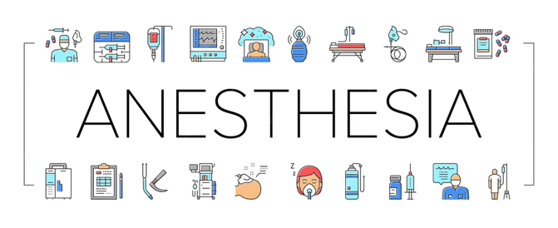
In the Zone Newsletter
December 2025

Welcome to In the Zone Newsletter, a resource designed to keep you informed, updated, and empowered in the evolving world of anesthesia.
This publication is dedicated to coding professionals, anesthesia providers, billers, and compliance teams who play a vital role in ensuring accurate documentation, compliance, and reimbursement.

As anesthesia services grow in complexity, staying informed is key to ensuring accurate reporting and financial integrity. I look forward to helping you stay ahead in this critical specialty.

📅 December Issue Highlights
- Chapter 12 ~ ICD-10-CM ~ 2026 Updates
- Overview of 2026 CPT Changes
- No Anesthesia Code Changes for 2026

ICD-10-CM 2026 Update: Chapter 12 – Diseases of the Skin and Subcutaneous Tissue (L00–L99)

Overview of 2026 Changes
Chapter 12 received one of the largest expansions in the FY 2026 ICD-10-CM update, with approximately 116 new codes. The updates primarily improve specificity for skin infections, soft tissue conditions, and non‑pressure chronic ulcers.

Key Additions: Flank-Specific Codes
New codes were added to identify the flank as a distinct anatomical site. These include:
• L02.217 – Cutaneous abscess of flank
• L02.227 – Furuncle of flank
• L03.31A – Cellulitis of flank
• L03.32A – Acute lymphangitis of flank
These codes support improved documentation and accurate reporting of flank-related soft tissue infections.

Major Expansion: Non‑Pressure Chronic Ulcers
A significant portion of the update includes new codes for non‑pressure chronic ulcers. These codes include details on anatomical site, laterality, and severity/depth such as:
• Breakdown of skin
• Fat layer exposed
• Muscle involvement or necrosis
• Bone involvement or necrosis
Example new abdomen ulcer codes:
• L98.431 – Non-pressure chronic ulcer of abdomen limited to breakdown of skin
• L98.432 – Fat layer exposed
• L98.433 – Necrosis of muscle
• L98.434 – Necrosis of bone
• L98.435 – Muscle involvement without necrosis
• L98.436 – Bone involvement without necrosis

Upper Limb Ulcer Additions
New categories allow coding of non-pressure ulcers of the upper arm, forearm, and hand with laterality. Codes specify depth, severity, and tissue involvement.

Guideline Considerations
The FY 2026 ICD-10-CM Official Guidelines include revisions clarifying documentation requirements for ulcer severity, anatomical precision, and infection site specificity. Providers should ensure adequate documentation to support these codes.

Impact on Coding and Clinical Practice
• Requires more detailed documentation of ulcer severity and exact anatomical site.
• Enhances accuracy in billing and clinical reporting.
• Coders should verify that charting supports the expanded specificity before assigning updated codes.
• Training may be required for both clinicians and coding staff to ensure compliant use of new codes.

Overview of CPT 2026 Changes
The 2026 CPT code update introduces significant changes, including 288 new codes, 46 revisions, and 84 deletions. These updates impact multiple specialties, particularly those involving digital health, cardiovascular care, remote monitoring, radiology, and interventional procedures.

Key Areas to Discuss in December
December is the final preparation month before the January 1, 2026 implementation of new CPT codes. Focus areas include:
• Understanding new and deleted codes
• Reviewing revised descriptions and guidelines
• Updating internal workflows and templates
• Ensuring providers understand documentation requirements
• Preparing billing and coding systems for changes

Major 2026 CPT Changes Worth Highlighting
• Digital Health & Remote Monitoring:
- New codes for short-duration remote physiologic monitoring (2–15 days)
- New monthly monitoring management codes with updated time thresholds
• Cardiovascular & Interventional Procedures:
- Major overhaul of lower-extremity revascularization codes
- New codes for complex coronary interventions
- Updated guidelines affecting add-on and bundled procedures
• AI-Assisted Diagnostics:
- New CPT codes for AI-supported image analysis such as cardiac risk scoring
- Requirements for clinician oversight and documentation
• Radiology & Imaging Updates:
- Several new and revised codes in diagnostic imaging and interventional radiology

Why December Preparation Is Critical
• New codes take effect January 1, 2026, with no grace period for using old codes.
• Payers will require appropriate CPT codes starting on the effective date.
• Training and workflow updates in December prevent claim denials in early 2026.
• Proper planning ensures providers document at the level of detail needed for accurate coding.

December Checklist for CPT 2026 Implementation
• Obtain the official CPT 2026 code book or digital update
• Identify high-impact areas based on your specialty or organization
• Update EHR templates, charge capture tools, and billing software
• Train coding, billing, and clinical staff on key changes
• Communicate payer-specific updates and policy changes
• Audit documentation and ensure compliance with new code requirements
• Establish internal workflows for managing new remote monitoring and AI-related codes

Final Recommendations
Use December to ensure you are fully prepared for CPT 2026 implementation. Early preparation minimizes workflow disruption, reduces errors, and supports accurate reimbursement when the updates take effect on January 1.
Wishing you a wonderful holiday season and a year filled with success, clarity, and continued excellence in anesthesia coding.

Committed to clarity in anesthesia coding,
Dianne C. Moseley, CPC, CPMA, CPCO

