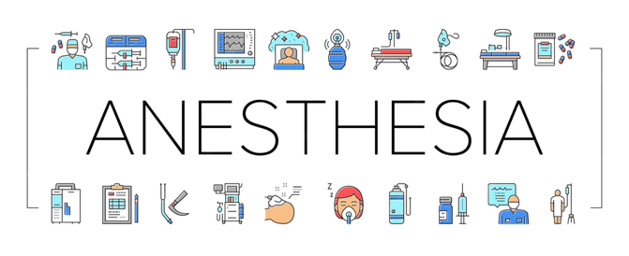
In the Zone Newsletter
October 2025

Welcome to In the Zone Newsletter, a resource designed to keep you informed, updated, and empowered in the evolving world of anesthesia.
This publication is dedicated to coding professionals, anesthesia providers, billers, and compliance teams who play a vital role in ensuring accurate documentation, compliance, and reimbursement.

What to Expect in Each Issue
- Coding updates and regulatory changes relevant to anesthesia and perioperative services
- Practical tips and best practices to improve documentation accuracy and reduce denials
- Spotlights on key CPT and ICD-10-CM codes including hemodynamic monitoring, pain procedures, and new coding guidelines
- Educational resources and case scenarios to support continuing education and team training

As anesthesia services grow in complexity, staying informed is key to ensuring accurate reporting and financial integrity. I look forward to helping you stay ahead in this critical specialty.

📅 First Issue Highlights
- New and revised anesthesia-related codes
- Documentation essentials for line placement (A-line, CVP, PA catheters)
- ICD-10-CM 2026 updates
- Compliance corner: avoiding common coding pitfalls

Let’s code smarter, together.

ICD-10-CM

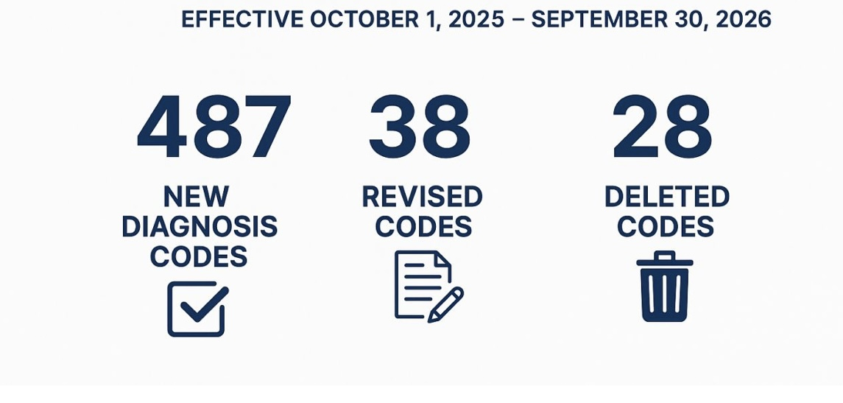

**New Code: E11.A – Type 2 Diabetes Mellitus in Remission**
For the first time, ICD-10-CM offers a specific code to capture when a patient with Type 2 diabetes mellitus has achieved remission. This reflects improved clinical accuracy and supports public health, research, and reimbursement systems.

Key Benefits of E11.A
Clinical Accuracy | Clearly differentiates remission from active disease or “history of” diabetes
Supports Quality Metrics | Enables tracking of remission rates in patient populations and registries.
Improves Communication | Aligns coding and documentation between providers, coders, and payers
Clarifies Care Planning | Acknowledges ongoing risk and the need for monitoring despite remission.

Documentation Tips
- Clearly state “Type 2 diabetes in remission” in the record.
- Ensure lab evidence of sustained normoglycemia (≥3 months recommended).
- Continue to document any related complications or risk factors.
- Avoid coding E11.A if hyperglycemia persists or diabetes is active

CPT 2026 effective January 1, 2026
Lower Extremity Revascularization Overhaul

- 16 existing codes (CPT 37220 – 37235) will be deleted.
- They are being replaced by 46 new codes within the 37254-37299 range.
- These codes are organized by vascular territory and complexity:
- Iliac artery
- Femoral & popliteal arteries
- Tibial & peroneal arteries:
- Inframalleolar arteries

Codes will distinguish:
- Type of intervention (e.g., angioplasty, atherectomy, stent)
- Single vs. multiple vessels
- Straightforward vs. complex lesions

The intent is to better reflect actual procedural work and lesion complexity than the old “one-size-fits-all” 37220-37235 structure.

Coding/Billing Implications
- Bundling rules will change: some services previously billed separately (e.g., angioplasty + stent) will be packaged under a single code
- Territory-based coding will replace vessel-based coding, reducing stacking of multiple codes for the same territory.
- Complexity tiers will impact RVUs and payment – especially for fem-pop and tibial interventions.

New and revised anesthesia-related codes
- No direct changes to core anesthesia CPT codes (00100-01999)
According to a CPT “In Review” summary, there are no new, revised, or deleted codes specifically in the anesthesia section for 2026. However, several significant updates affect anesthesiology and pain management professionals, including the introduction of new chronic pain codes and changes to the anesthesia conversion factor.

More to come on updated CPT codes.

Changes to the anesthesia conversion factor
For 2026, CMS is implementing two different anesthesia conversion factors (CFs) based on physician participation in an Alternative Payment Model (APM).

- The new payment structure offers different update percentages depending on APM participation.
- While this will result in a modest increase in the anesthesia CF, the ASA has noted that the updates are low and will not relieve financial pressures on anesthesia groups.

Updates to the Quality Payment Program (QPP)
For anesthesiologists reporting under the Merit-based Incentive Payment System (MIPS) in 2026:
- The performance threshold will remain at 75 points.
- CMS has proposed adding three new anesthesiology quality measures.
- Two quality measures are proposed for removal from the Anesthesiology MIPS Value Pathway:
  - QID424: Perioperative Temperature Management
  - QID487: Screening for Social Drivers of Health

🩺 1. Core Documentation Elements (All Line Placements)

For any line placement, your note should clearly document:
- Indication / Medical Necessity
  - Hemodynamic monitoring
  - Frequent arterial blood sampling
  - Administration of vasoactive medications
  - Poor peripheral access, etc.
- Date and Time of Placement
  - Important for both billing and clinical tracking.
- Site / Anatomical Location
  - Specify exact vessel and laterality:
    - Example: Right radial artery, Left subclavian vein, Right internal jugular vein.
- Type of Line / Catheter
  - Arterial line
  - Central venous catheter (CVC)
  - Pulmonary artery (PA) catheter
  - Introducer, triple lumen, etc.
- Sterile Technique & Prep
  - Document adherence to sterile technique, prep solutions, and draping.
  - Example: “Maximal sterile barrier precautions used. Skin prepped with chlorhexidine.”
- Technique Used
  - Ultrasound guidance vs. landmark technique
  - Number of attempts
  - Confirmation of placement
    - (e.g., waveform, blood return, transduction, ultrasound confirmation, CXR)
- Complications / Events
  - None vs. describe specific issue
  - Example: “No immediate complications.”
- Operator / Supervision
  - Full name, credentials, and role.
- Patient Tolerance / Outcome
  - Example: “Patient tolerated procedure well, hemodynamically stable.”

💉 2. Specific Line Types

A. Arterial Line
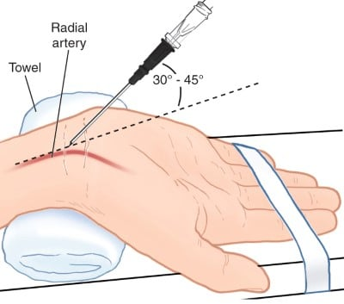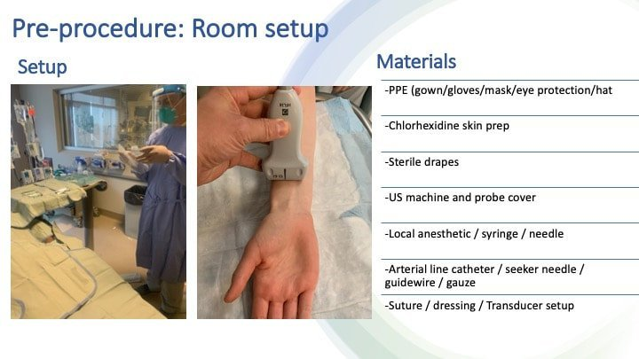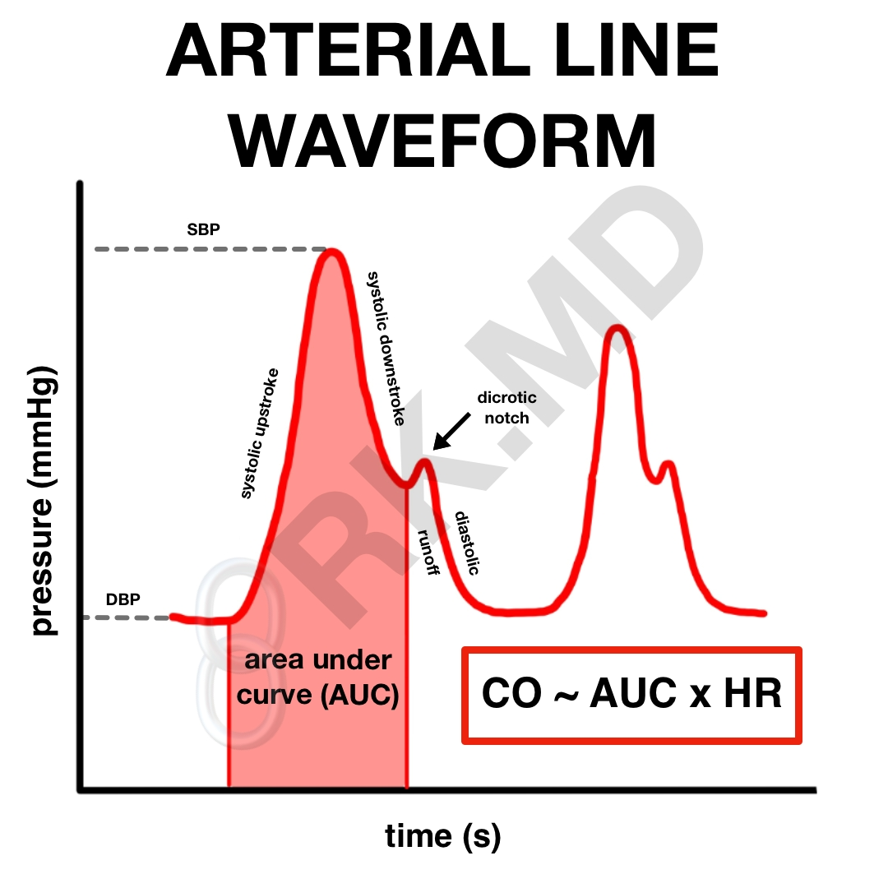
CPT: 36620
Required documentation:
- Indication for arterial monitoring
- Site (e.g., radial, femoral)
- Technique (e.g., ultrasound used or not)
- Confirmation of waveform
- Complications or lack thereof
- Patient tolerance
📝 Sample phrasing:
“Right radial arterial line placed under sterile conditions with chlorhexidine prep using Seldinger technique. Good pulsatile flow, waveform confirmed. One attempt. No complications.”

B. Central Venous Catheter (CVC)
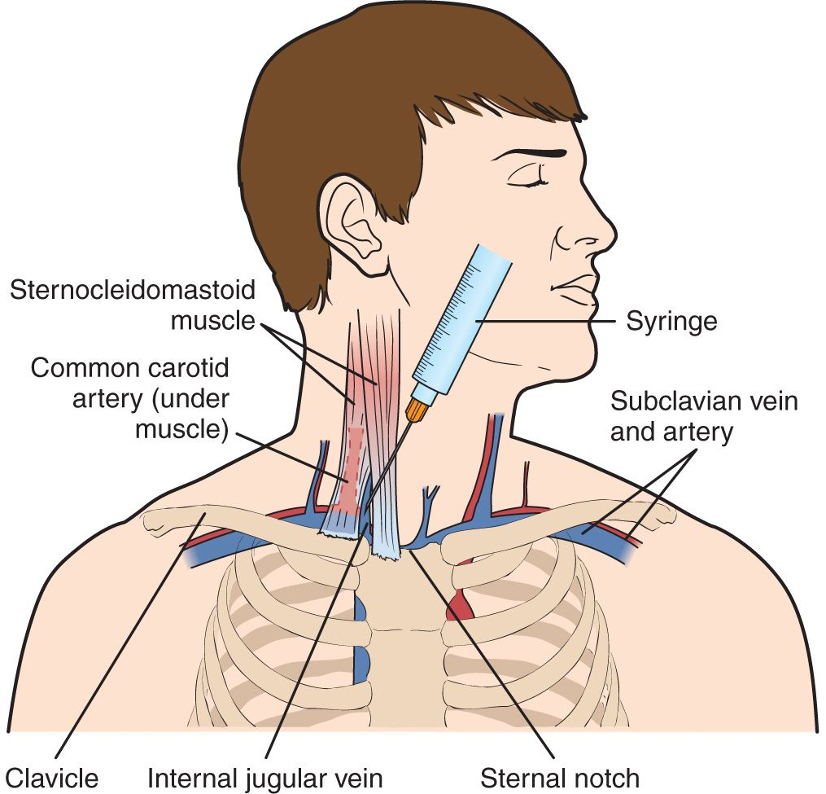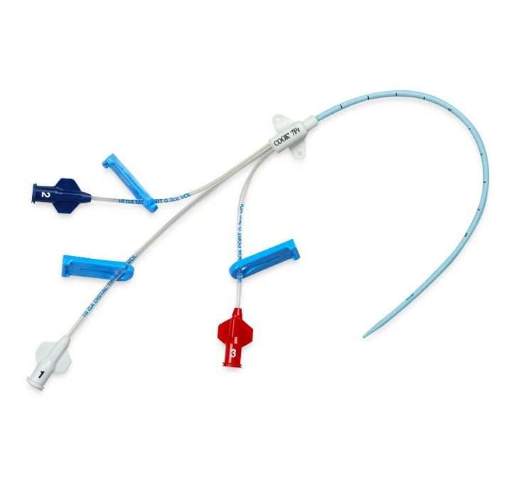

CPT: 36555 (age <5), 36556 (age ≥5)

Required documentation:
- Indication (e.g., vasoactive drug administration, monitoring, poor access)
- Site and side (e.g., right internal jugular)
- Device type (e.g., triple lumen, introducer)
- Technique (landmark or ultrasound)
- Confirmation of venous placement (blood return, ultrasound, pressure transduction)
- Chest X-ray ordered / reviewed if indicated
- Complications
- Patient tolerance
📝 Sample phrasing:
“Right internal jugular central venous catheter placed under ultrasound guidance with sterile technique. Triple lumen catheter advanced smoothly. Good blood return from all ports. Line flushed easily. CXR pending. No complications.”

C. Pulmonary Artery Catheter (PAC)
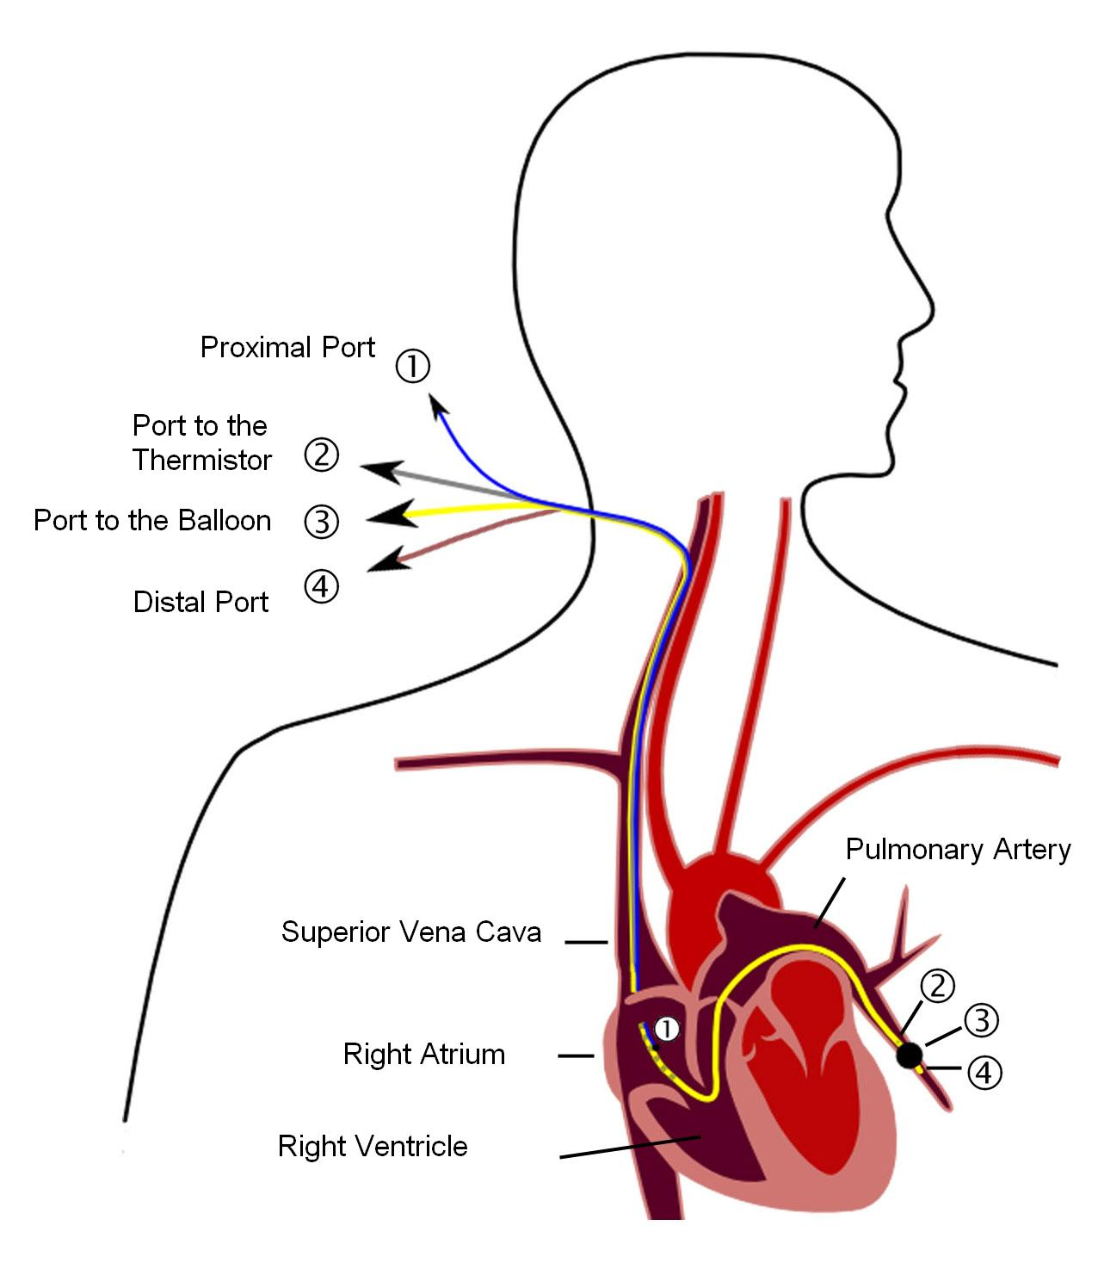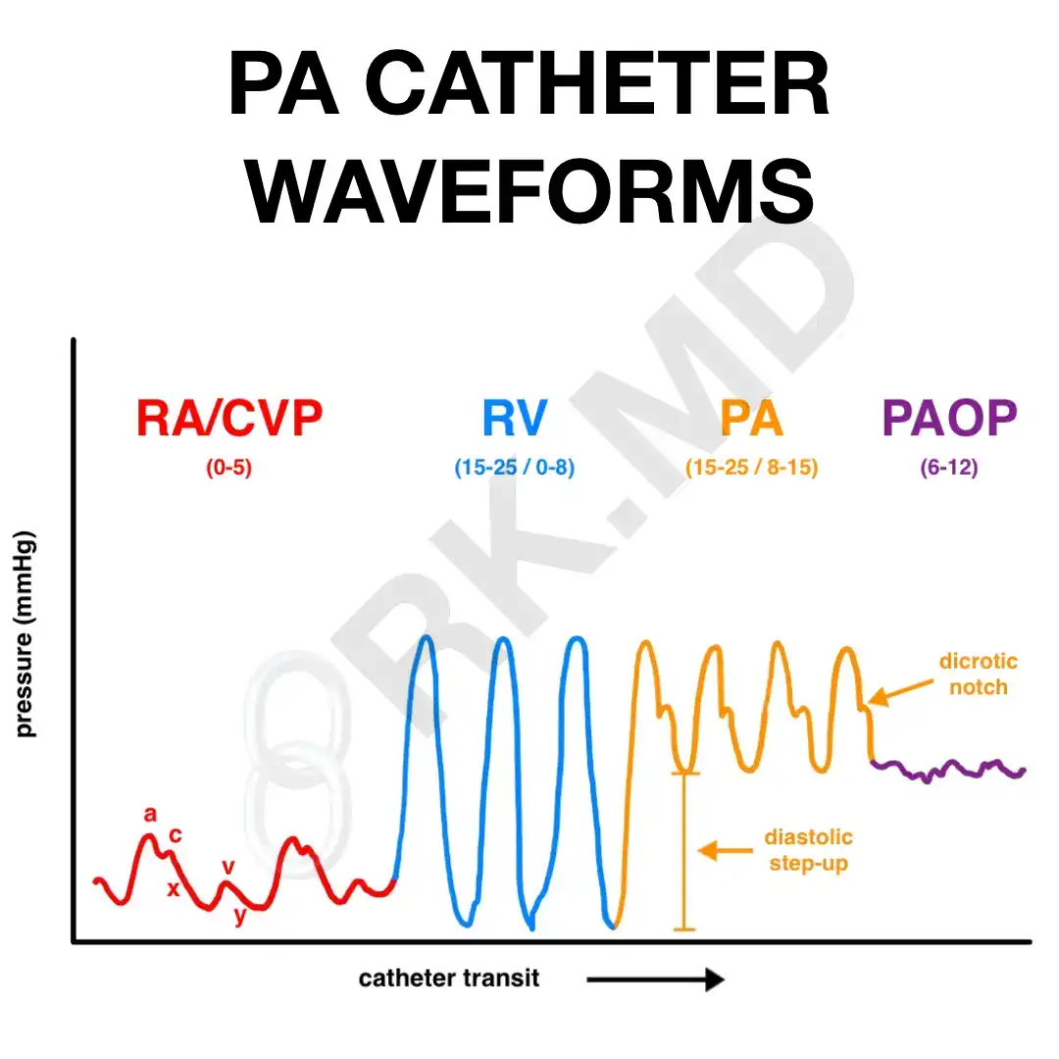
CPT: 93503

Required documentation:
- Indication (e.g., advanced hemodynamic monitoring in cardiac surgery, shock)
- Site and approach
- Type of catheter (e.g., Swan-Ganz)
- Technique (e.g., floated through introducer)
- Confirmation of wedge position and pressure waveforms
- Complications or lack thereof
- Patient tolerance
📝 Sample phrasing:
“PA catheter inserted via right internal jugular introducer under sterile conditions. Catheter floated to wedge position with appropriate pressure waveform confirmation. Hemodynamics obtained. No complications.”

🧼 3. Procedural Documentation Best Practices
- Use standardized language: Helps support medical necessity and streamline coding.
- Include ultrasound use: If ultrasound guidance was used, document it clearly — it may impact reimbursement.
- Avoid ambiguous statements: “Line placed” without site, indication, or technique can lead to denials.
- Document unsuccessful attempts separately if applicable.
- Link to operative or anesthesia record to avoid duplicate billing issues.

🏥 4. Coding & Billing Tips
Procedure | CPT Code | Key Doc Requirement | Typical ASA Base Units
Arterial line | 36620 | Site, indication, technique | 0 (bundled with anesthesia base)
CVC ≥5 yrs | 36556 | Site, technique, confirmation | Billable
CVC <5 yrs | 36555 | Same as above | Billable
PA Catheter | 93503 | Indication, waveform confirmation | Billable
Ultrasound guidance (if not bundled) | 76937 | Document real-time guidance + image capture | Billable

📌 5. Quick Checklist for Documentation
✅ Indication
✅ Date / Time
✅ Site and laterality
✅ Type of line / catheter
✅ Technique (sterile prep, guidance, number of attempts)
✅ Confirmation method
✅ Complications / patient tolerance
✅ Operator info / signature

🛡 Compliance Corner: Avoiding Common Coding Pitfalls
Accurate coding protects your organization from compliance risks, denials, and revenue loss. Even small errors can create big problems during audits or payer reviews. Below are some frequent pitfalls and strategies to avoid them:

⚠️ 1. Missing or Incomplete Documentation
- Pitfall: Coding without supporting documentation for time, procedure details, or medical necessity.
- Compliance Tip: Always ensure anesthesia start/stop times, ASA physical status, procedure notes, and monitoring details are documented clearly and legibly.

🩺 2. Unbundling or Double Billing
- Pitfall: Reporting separately billable services that are already included in the primary anesthesia service.
- Compliance Tip: Verify when procedures such as arterial line placement (e.g., CPT 36620) or CVP line insertion (e.g., CPT 36556) may or may not be billed separately.

🧾 3. Incorrect ASA Crosswalk or Modifiers
- Pitfall: Using the wrong ASA CPT crosswalk or omitting modifiers such as QX/QZ, AA, or QS.
- Compliance Tip: Confirm ASA code selection aligns with the surgical CPT code and apply the correct modifier to reflect the provider type and level of involvement.

🩸 4. Overlooking Medical Necessity
- Pitfall: Assigning diagnosis codes that do not support the medical necessity of the procedure.
- Compliance Tip: Align CPT and ICD-10-CM codes correctly. For example, arterial line monitoring requires appropriate hemodynamic indications (e.g., hypertension, sepsis, or shock).

📅 5. Failing to Stay Current with Code Updates
- Pitfall: Using outdated CPT or ICD-10-CM codes after October 1 or January 1 updates.
- Compliance Tip: Review annual updates (e.g., American Medical Association CPT changes and ICD-10-CM revisions) and ensure internal cheat sheets and EHR templates are updated.

🧭 6. Not Following Payer-Specific Rules
- Pitfall: Assuming all payers follow the same billing policies.
- Compliance Tip: Check payer contracts and coverage policies for bundling rules, time units, or modifier usage.

✅ Best Practices to Stay Audit-Ready
- Perform regular internal audits.
- Use checklists for anesthesia documentation.
- Provide coding education to providers and billing staff.
- Keep quick references updated with the latest CPT and ICD-10-CM changes.
- Document medical necessity and time accurately — every time.

Committed to clarity in anesthesia coding,
Dianne C. Moseley, CPC, CPMA, CPCO
Editor, In the Zone

